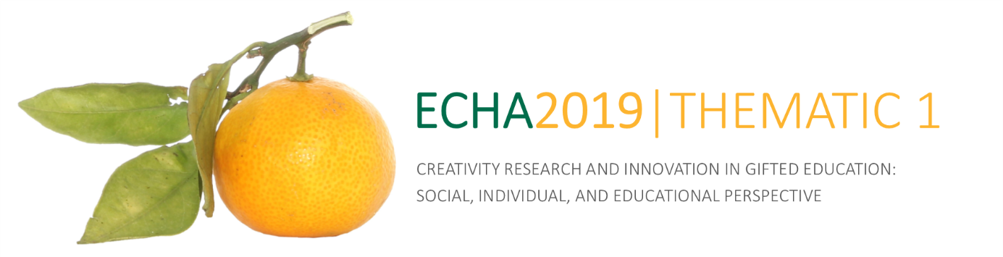
SUBMITTED MANUSCRIPT PEER-REVIEW FORM

Respected Reviewer, thank you for reviewing the manuscript submitted for the publication in the conference proceedings of the 1st Thematic ECHA Conference entitled Creativity Research and Innovation in Gifted Education: Social, Individual, and Educational Perspective, held in the city of Dubrovnik from 16th to 18th October 2019.
Note. Upon review, please return this Review form to: echa.thematic2019@gmail.com

General data on submitted manuscript

Title:
No. of pages:
No. of references:

Submitted manuscript evaluation | Put “+” in the appropriate column to evaluate the manuscript quality according to the listed criteria
 | Poor | Average | Good | Excellent
Theoretical/Conceptual Framework/ Introduction
Literature Review
Statement of the problem
Significance of the Research
Methodology
Quality of Data or Findings
Results and Conclusions
Originality of the manuscript and its contribution to the field
Readability and Writing Style
Relevant references

Other issues (please indicate):

Choose YES or NO to evaluate the manuscript according to the listed criteria
(mark your choice by bolding it)

The manuscript follows the instructions for authors on the website | YES | NO
The manuscript follows the APA standards | YES | NO

Overall evaluation
(mark your choice by bolding it)

Professional article | Original scientific article | Review article

Overall evaluation
(mark your choice by bolding it)

Reject | Decision after major revision | Accept with minor revision | Accept as is
Would you be willing to review a revision of this manuscript? YES NO

Based on your overall evaluation, please provide arguments for your decision and recommendations on improvements and revisions.

Reviewer’s personal data
Name:
Title:
Organization:
Email:
I hereby state that the submitted review has been carried out objectively and is solely based on professional, scientific and ethical standards.

Date:

Reviewer’s signature:

